VISVESVARAYA TECHNOLOGICAL UNIVERSITY

Jnana Sangama, Belagavi-590014, Karnataka, INDIA



**MINI PROJECT REPORT**

ON

**“Book Planet –** **An Online Book Store”**

**Subject: DBMS Laboratory (15CSL58)**

**Bachelor Of Engineering (Information Science & Enginnering)**

2018-19

|  |  |
| --- | --- |
| GUIDANCE BY:  MRS. SHANTA BIRADAR  Assistant Professor B.E, MTech, (Ph.D.)  Department of Information Science & Engineering  MR. MANOHAR R  Assistant Professor B.E, MTech, (Ph.D.)  Department of Information Science & Engineering | SUBMITTED BY:  DEEP NARAYAN TANDAN  1MV17IS018  Information Science & Engineering  PANKAJ KUMAR BHATI  1MV17IS035  Information Science & Engineering |



**Department Of Information Science & Engineering**

**Sir M. Visvesvaraya Institute Of Technology**

Hunsumaranhalli, Bangalore-562157

CERTIFICATE

It is certified that the project work entitled “ **BOOK PLANET - AN ONLINE BOOK STORE**” is a bonafide work carried out by **Deep Narayan Tandan** (1MV17IS018) **& Pankaj Kumar Bhati** (1MV17IS035) in partial fulfillment for the requirements of DBMS mini project for the V semester curriculum  Bachelor of Engineering in Information Science and Engineering of the Visvesvaraya Technological University, Belagavi during the year 2019-2020 .

It is certified that all corrections and suggestions indicated for Internal Assessment have been incorporated in the report. The project report has been approved as it satisfies the academic requirements in respect of Project work prescribed for the course of Bachelor of Engineering.

|  |  |
| --- | --- |
| Name & Signature of Guide  MRS. SHANTA BIRADAR  Assistant Professor B.E, M.Tech, (Ph.D.)  Department of Information Science & Engineering  Sir M. Visvesvaraya Institute Of Technology  Bangalore - 562157 | Name & Signature of HOD  Dr. P. VIJAYAKARTHIK  Professor & HOD B.E, M.E, P.HD  Department of Information Science & Engineering  Sir M. Visvesvaraya Institute Of Technology  Bangalore - 562157 |

**External Examination:**

Name of the Examiners                                                        Signature with Date

1)

2)

**ACKNOWLEDGMENT**

It gives us immense pleasure to express our sincere gratitude to the management of **Sir M. Visvesvaraya Institute of Technology,** Bangalore for providing the opportunity and the resources to accomplish our project work on their premises.

On the path of learning, the presence of an experienced guide is indispensable and we would like to thank our guide **Mrs. Shanta Biradar,** Assistant Professor, Department of Information Science & Engineering, for her invaluable help and guidance.

We would also like to convey our regards and sincere thanks to **Dr. P. Vijayakarthik,** HOD, Department of Information Science & Engineering for his suggestions, constant support, and encouragement. Heartfelt and sincere thanks to **Dr. V.R. Manjunath,** Principal, Sir M. Visvesvaraya Institute Of Technology for providing us with the infrastructure and facilities needed to develop our project.

We would also like to thank the staff of the Department of Information Science and Engineering and lab-in-charges for their co-operation and suggestions. Finally, we would like to thank all our friends for their help and suggestions without which completing this project would not have been possible.

DECLARATION

We hereby declare that the entire mini project work embodied in this dissertation has been carried out by us and no part has been submitted for any degree or diploma of any institution previously.

Place: Bangalore

Date:

SIGNATURE OF STUDENTS:

Deep Narayan Tandan

(1MV17IS018)

Pankaj Kumar Bhati

(1MV17IS053)

**ABSTRACT**

The purpose of the **BOOK PLANET - AN ONLINE BOOK STORE** is to automate the purchase of books of the existing manual system with the help of computerized equipment and full-fledged computer web based application, fulfilling their requirements so that their valuable data information can be stored for a longer period with easy accessing and manipulation of the same. The required web application and hardware are easily available and easy to work with.

**BOOK PLANET - AN ONLINE BOOK STORE**, as described above, is designed in such a way that user can easiy purchase any book online available in in the inventory and get an electronic receipt with SMS and email notification regarding details of the purchase and also we provide the facility of shipment of the book to doorstep. Users can pay online through debit or credit cards easily with our secured transaction methods.

**BOOK PLANET - AN ONLINE BOOK STORE**, as described above, can lead to error free, secure, reliable and fast book purchasing systems. It can assist the owner to concentrate on their other activities rather concentrate on record keeping. Thus, it will help the organization in better utilization of resources. The organization can maintain computerized records without redundant entries. That means that one need not be distracted by information that is not relevant while being able to reach the information.

The aim is to automate its existing manual system with the help of computerized equipment and full-fledged computer software, fulfilling their requirements, so that their valuable data/information can be stored for a longer period with easy accessing and manipulation of the same. Basically, the project describes how to manage for good performance and better services for the clients.

TABLE OF CONTENTS

|  |  |  |
| --- | --- | --- |
| Content  INTRODUCTION  MAIN OBJECTIVES  SCOPE OF THE PROJECT BOOK PLANET  REPORTS OF BOOK PLANET  MODULES OF ONLINE BOOKSTORE  FEATURES OF THE PROJECT BOOK PLANET  SOFTWARE REQUIREMENTS  HARDWARE REQUIREMENTS  TABLES & DATA TYPES  SCHEMA DIAGRAM  E R DIAGRAM  RESULTS AND SNAPSHOTS  CONCLUSION  FUTURE SCOPE OF THE PROIECT  REFERENCES AND BIBLIOGRAPHY | Page Number  07  08  09  10  10  11  12  12  13  14  15  16  25  26 |  |

**INTRODUCTION**

The " **BOOK PLANET - AN ONLINE BOOK STORE** " has been developed to override the problems prevailing in the practicing manual system. This software is supported to eliminate and, in some cases, reduce the hardships faced by this existing system. Moreover, this system is designed for the particular need of the company to carry out operations in a smooth and effective manner.

The application is reduced as much as possible to avoid errors while entering the data. It also provides error message while entering invalid data. No formal knowledge is needed for the user to use this system. Thus, all it proves is a user-friendly **BOOK PLANET**, as described above, can lead to error free, secure, reliable and fast management systems. It can assist the user to concentrate on their other activities rather concentrate on record keeping. Thus it will help the organization in better utilization of resources.

Every organization, whether big or small, has challenges to overcome and manage the information of Stock, Books, Order, Bill, Payment. Every BOOK PLANET has different Book needs, therefore we design exclusive employee management systems that are adapted to your managerial requirements.

This is designed to assist in strategic planning and will help you ensure that your organization is equipped with the right level of information and details for your future goals. Also, for those busy executives who are always on the go, our systems come with remote access features, which will allow you to manage your workforce anytime, at all times. These systems will ultimately allow you to better manage resources.

**MAIN OBJECTIVES**

The main objective of the Project on **BOOK PLANET - AN ONLINE BOOK STORE** is to manage the details of Books, Stock, Customer, Order, Payment manages all the information about Books, Bill, Payment, Books. The project is totally built at the administrative end and thus only the administrator is guaranteed access. The purpose of the project is to build an application program to reduce the manual work for managing the Books, Stock, Bill, Customer. It tracks all the details about the Customer, Order, Payment.

FUNCTIONALITIES PROVIDED BY BOOK PLANET ARE AS FOLLOWS

* It provides search facilities based on various factors. Such as Books, Customer, Order, Payments.
* BOOK PLANET also manages the Bill details online for Order details, Payment details, book inventory.
* It also tracks all the information of Stock, Bill, Order, etc
* Manage the information of Stock, shows the information and description of the Books, Customer on the board and others.
* To increase the efficiency of managing the Books, Stock
* It deals with monitoring the information and transactions of Order, manage the information of books.
* Editing, adding and updating Records is improved which results in proper resource management of Book data.
* Manage the information of Orders purchased through the web application.

**SCOPE OF THE PROIECT BOOK PLANET**

It may help in collecting perfect management in detail. In a very short time, the collection will be obvious, simple and sensible. It will help a person to know the management of passing year perfectly and vividly. It also helps in current all works relative to the BOOK PLANET. t will be also reduced the cost of collecting the management & collection procedure will go on smoothly.

Our project aims at Business process automation, i.e. we have tried to computerize various processes of **BOOK PLANET - AN ONLINE BOOK STORE**.

* In a computer system, the person has to fill he various forms & number of copies of the forms that can be easily generated at a time.
* In a computer system, it is not necessary to create the manifest but we can directly print it, which saves our time.
* To utilize resources in an efficient manner by increasing their productivity through automation
* To assist the staff in capturing the effort spent on their respective working areas.
* The system generates types of information that can be used for various purposes
* It satisfies the user requirements of hasel free and amazing customer experience.
* Be easy to understand by the user and operator and be easy to operate.
* Have a good user interface and expandable
* Delivered on schedule within the budget with our courier partner option.

**Reports of Book Planet - An Online Book Store**

* It generates the report on Books, Stock, Bill
* Provide filter reports on Customer, Order, Payment
* You can easily export PDF for the Books, Bill, Order
* Applicaton also provides excel export for Stock, Customer, Payment
* You can also export the report into csv format for Books, Stock, Payment

**Modules of Book Planet - An Online Book Store**

* Books Management Module: Used for managing the book details.
* Payment Module: Used for managing the details of Payment
* Bill Module: Used for managing the details of Bill
* Stock Management Module: Used for managing the information and details of the Stock.
* Customer Module Used for managing the Customer details
* Order Module Used for managing the Order information
* Login Module: Used for managing the login details
* Users Module: Used for managing the users of the system
* Admin Module: Used for showing realtime data for admin from the backend database.

**FEATURES OF THE PROJECT BOOK PLANET - AN ONLINE BOOK STORE**

* Product and Component based
* Creating & Changing Issues at ease
* Query Issue List to any depth
* Reporting & Charting in a more comprehensive way
* User Accounts to control the access and maintain security
* Simple Status & Resolutions
* Multi-level Priorities & Severities.
* Targets & Milestones for guiding the programmers
* Attachments & Additional Comments for more information
* Robust database back-end
* Various level of reports available with a lot of filter criteria's
* It contains a better storage capacity.
* Accuracy in work.
* Easy & fast retrieval of information
* Well designed reports.
* Decrease the load of the person involves in the existing manual system.
* Access to any information individually.
* Work becomes very speedy.
* Easy to update information

**SOFTWARE SPECIFICATIONS**

**Name of component** **Specification**

1. Operating System Windows & Linux
2. Language PHP, JavaScript, HTML, CSS
3. Database MySQL
4. Browser Google Chrome, Mozilla Firefox
5. Web server Xampp (PHPMyAdmin)
6. Software development kit Bootstrap and VueJS

**HARDWARE SPECIFICATIONS**

**Name of component Specification**

1. Processor i5 7th gen and above
2. Ram Minimum 1GB
3. Hard Disk 40GB and above
4. Monitor 15" color monitor
5. Keyboard 122 keys

TABLES AND DATATYPES

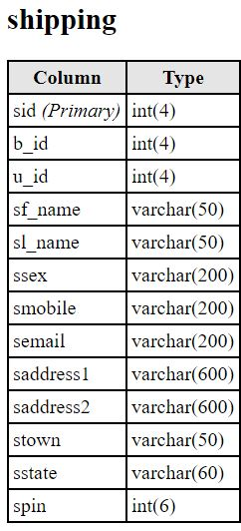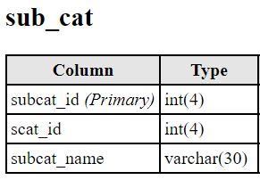

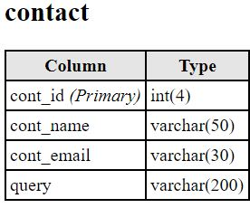

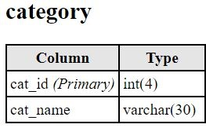

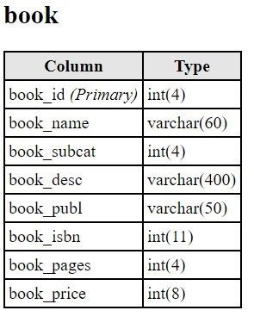

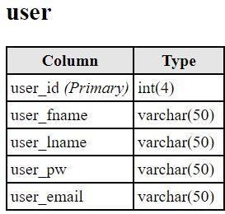

SCHEMA DIAGRAM

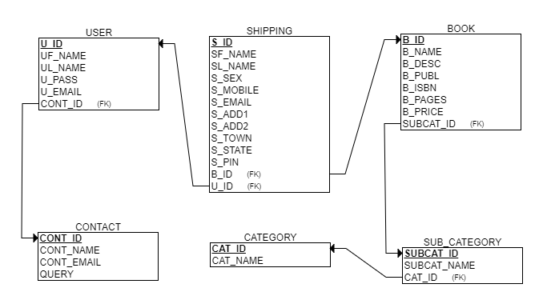

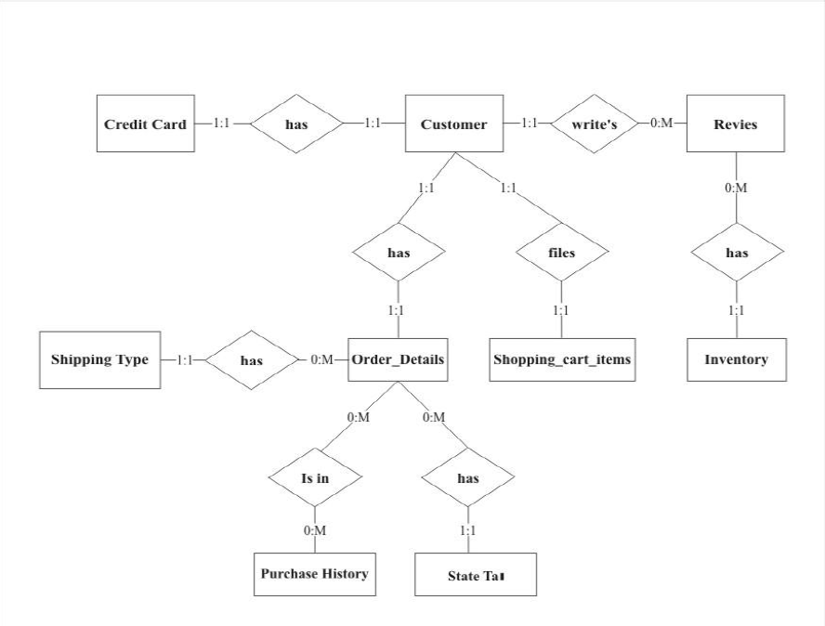ER DIAGRAM

**RESULTS AND SNAPSHOTS**

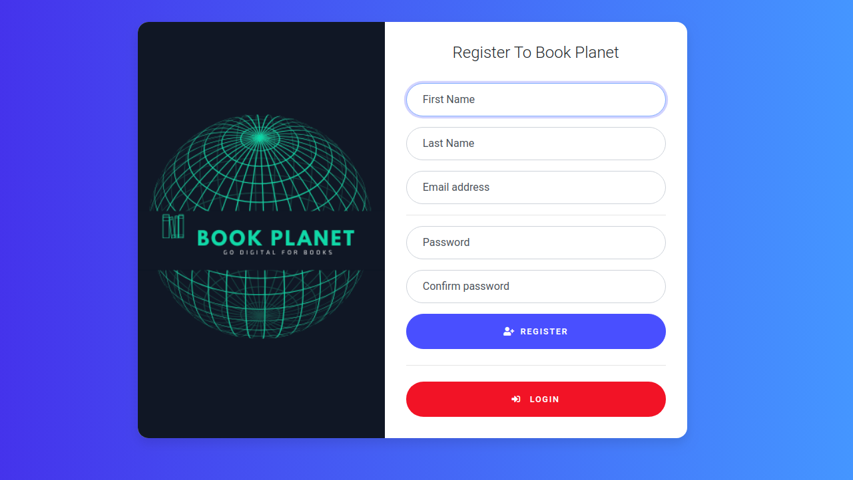

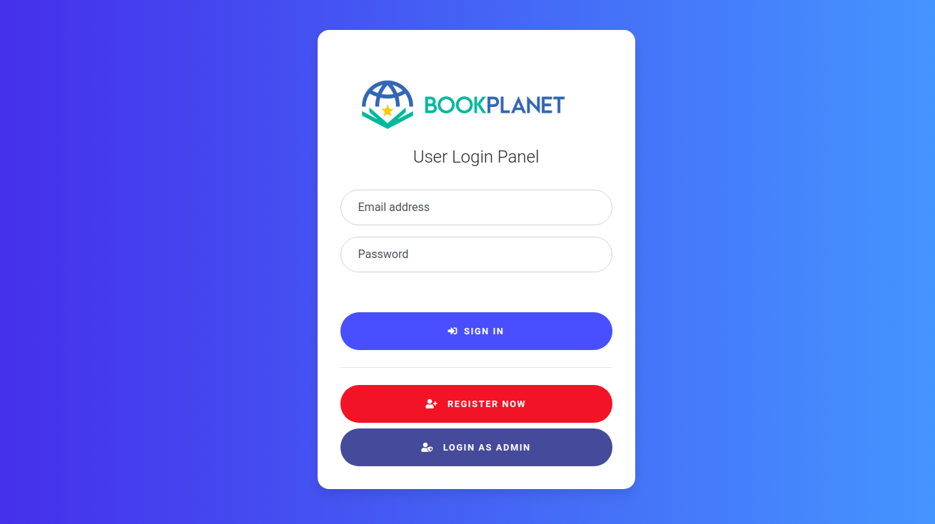

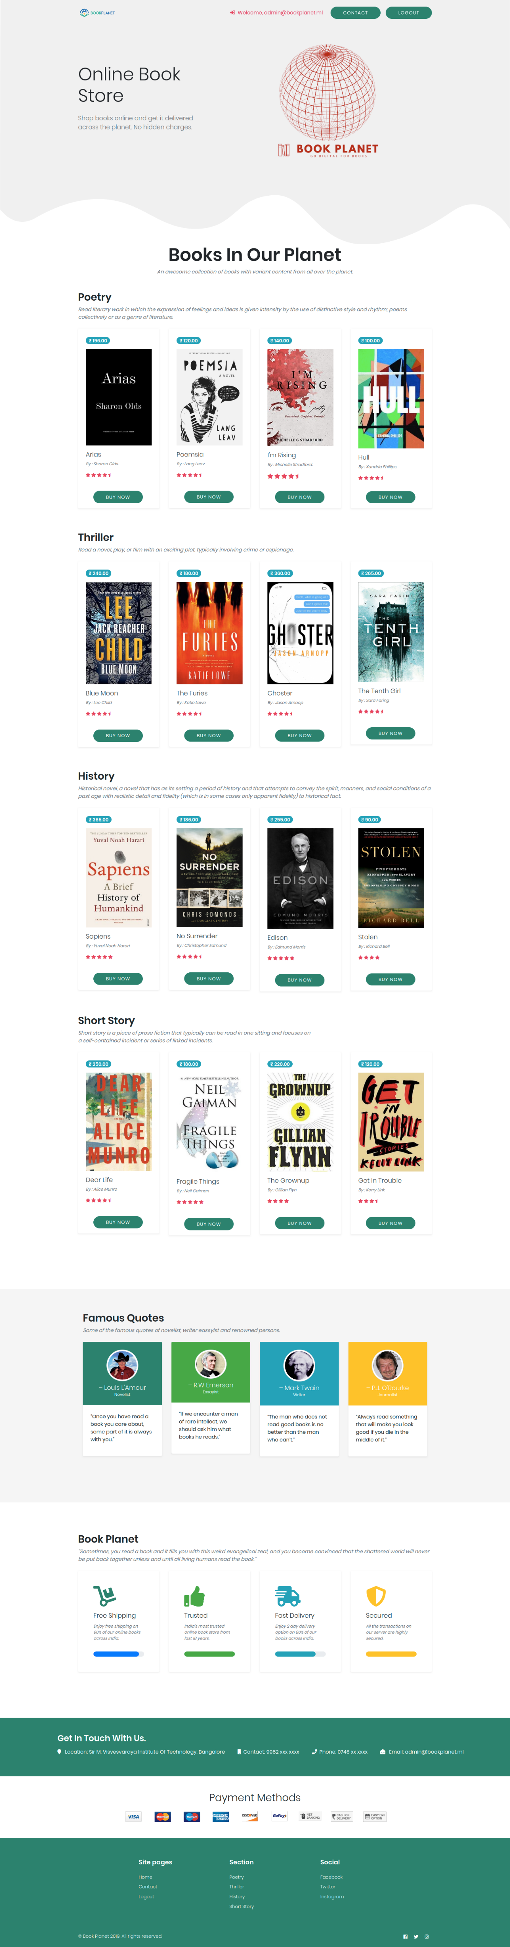

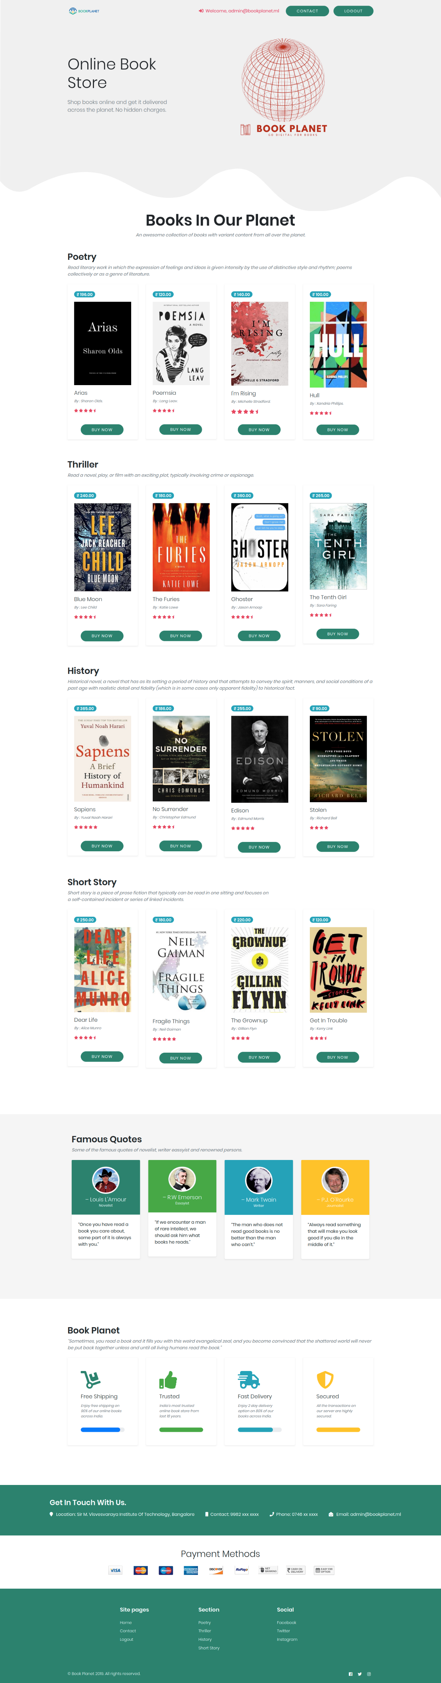

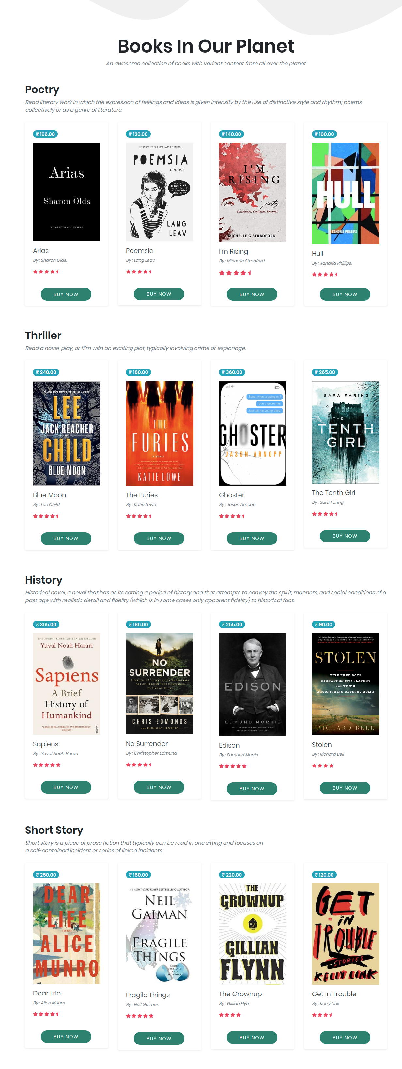re.

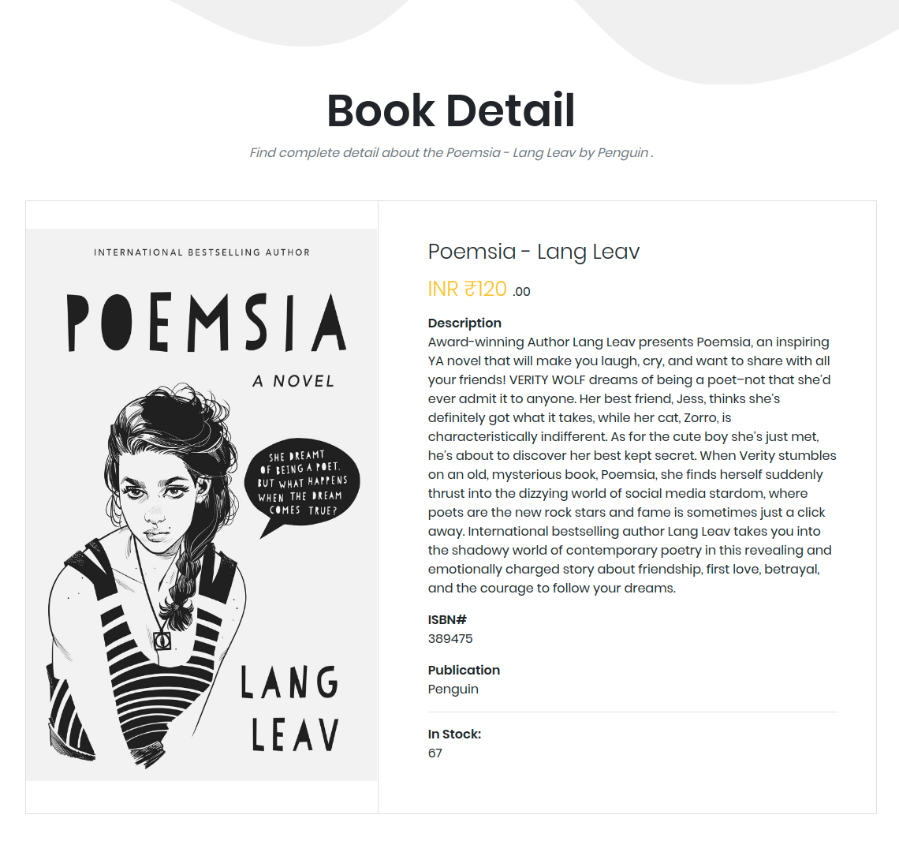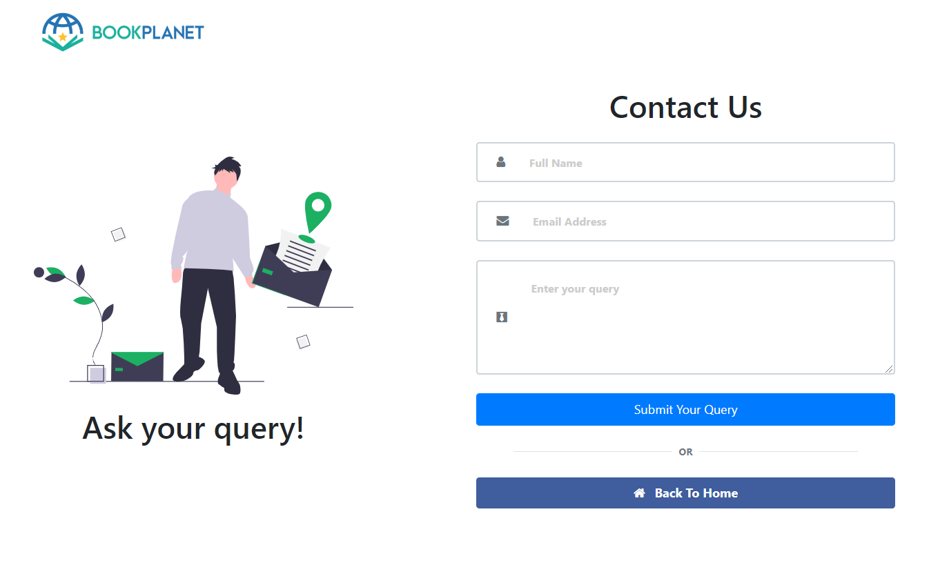

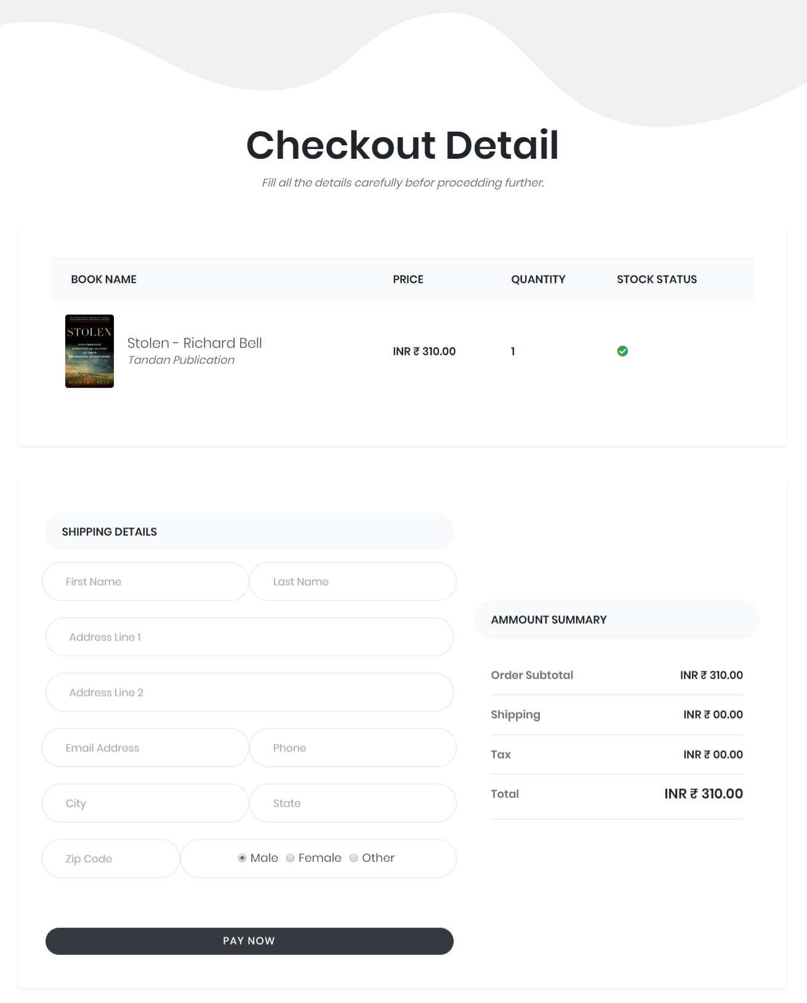

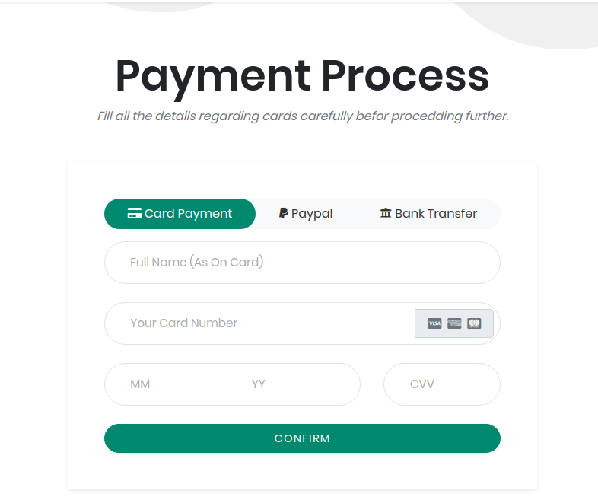

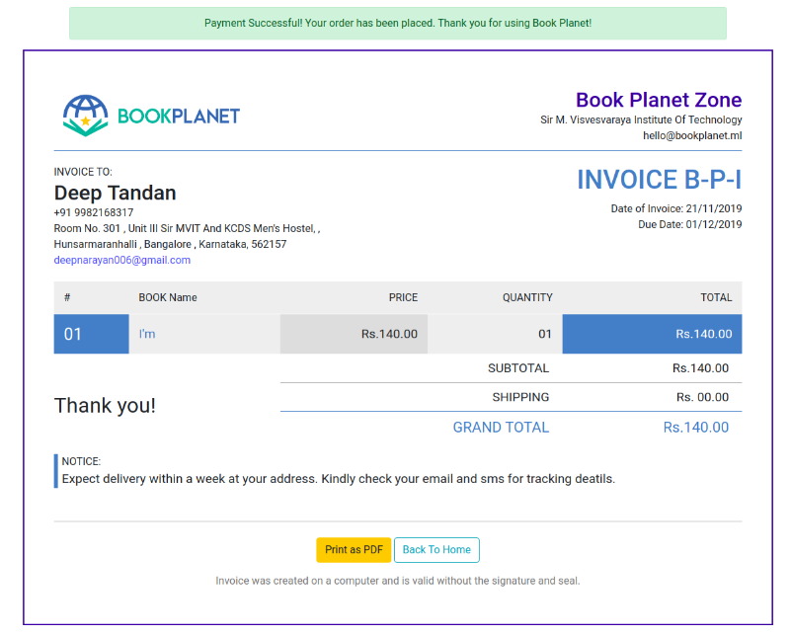

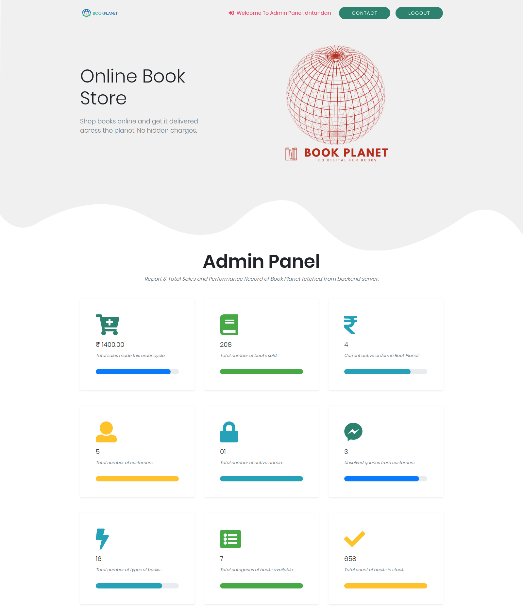

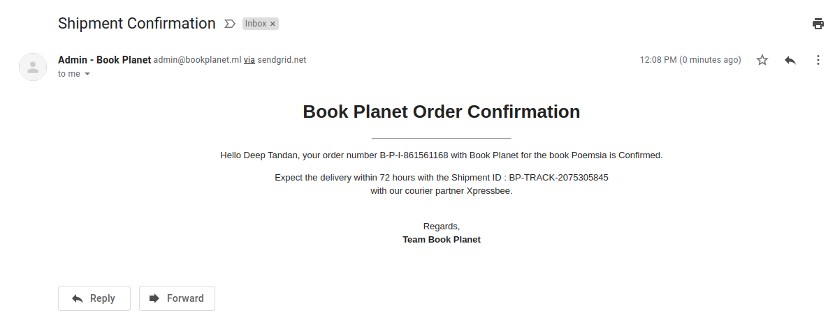

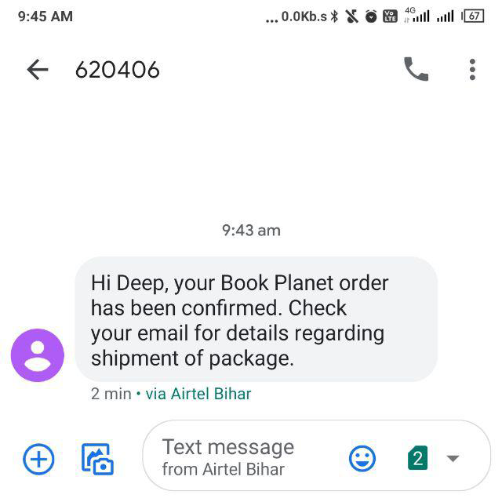

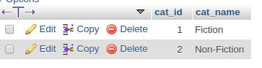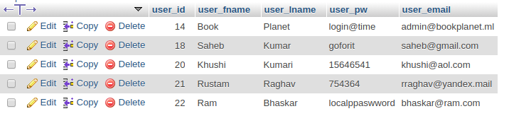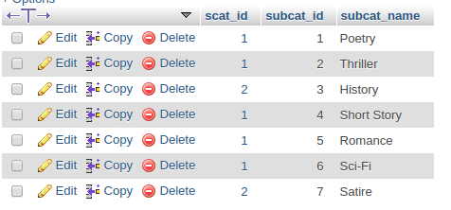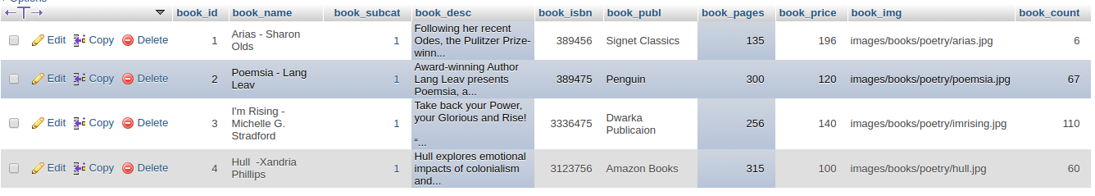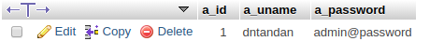—

**CONCLUSION OF PROJECT**

Our project is only a humble venture to satisfy the needs to manage their project work. Several user-friendly coding has also adopted. This package shall prove to be a powerful package in satisfying all the requirements of the school. The objective of software planning is to provide a frame work that enables the manger to make reasonable estimates made within a limited time frame at the beginning of the software project and should be updated regularly as the project progresses.

**In the end, it is concluded that we have made an effort on the following points**

* A description of the background and context of the project and its relation to work already done in the area.
* Made a statement of the aims and objectives of the project.
* The description of Purpose, Scope, and applicability.
* We define the problem on which we are working in the project.
* We describe the requirement Specifications of the system and the actions that can be done on these things.
* We understand the problem domain and produce a model of the system, which describes operations that can be performed on the system.
* We included features and operations in detail, including screen layouts.
* We designed the user interface and security issues related to system
* Finally, the system is implemented and tested according to test cases.

**FUTURE SCOPE OF THE PROIECT**

In a nutshel, it can be summanized that the future scope of the project circles around maintaining information regarding:

* We can add a printer in the future which will directly print the receipt of each order placed for admin.
* We can give more advance software for BOOK PLANET induding more facilities.
* We will host the platform on online servers to make it accessible worldwide.
* Integrate multiple load balancers to distribute loads of the system.
* Create the master and slave database structure to reduce the overload of the database queries
* Implement the backup mechanism for taking the backup of codebase and database on a regular basis on different servers.

The above mentioned points are the enhancements which can be done to increase the applicability and usage of this project Here we can maintain the records of Books and Stock. Also, as it can be seen that now-a-days the players are versatile, i.e. so there is a scope for introducing a method to maintain the **BOOK PLANET**. Enhancements can be done to maintain all the Books, Stock, Customer, Order and Payments.

We have left all the options open so that if there is any other future requirement in the system by the user for the enhancement of the system then it is possible to implement them.

In the last, we would like to thanks all the persons involved in the development of the system directly or indirectly. We hope that the project will serve its purpose for which it is developed there by underlining the success of the process and synopsis of **BOOK PLANET**.

**REFERENCES AND BIBLIOGRAPHY**

* <https://www.w3schools.com/>
* https://fontawesome.com/
* http://www.sendgrid.com /
* http://www.textlocal.com/
* https://getbootstrap.com/
* https://bootstrapious.com/
* https://www.tutorialspoint.com/javal
* http://www.JSP.net/
* http://www.javatpoint.com/java-tutorial
* https:lldocs.oracle.com/javase/tutorial/
* http://www.wampserver.com/en/
* https://www.coursera.org/specializations/data-warehousing
* https://www.tutorialspoint.com/dbms/
* Google for problem solving
* https://stackoverflow.com/dbms
* Database Programming with JDBC and Java by O'Reily
* Head First Java 2nd Edition
* Java and Software Design Concepts by Apress
* http://www.tutorialspoint.com/mysql
* httpd.apache.org/docs/2.0/misc/tutorals.html